General Physics II Lab
Ohm’s law and non-ohmic devices

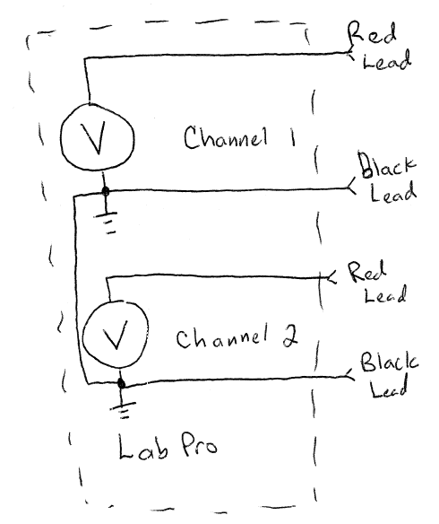
Voltmeters are devices that are used to measure the potential difference between points on a circuit. Some current must flow to the voltmeter in order for the potential to be measured, but this current is very low (typically below one microamp). Because this current is so low, voltmeters allow the potential difference between two points to be measured with very little effect on the circuit being probed.

The LabPro interface can measure the potential differences from -10V to +10V referenced from a common “ground”. Schematically, the LabPro can be represented by up to four voltmeters (the circle with a V inside), with one side of each voltmeter connected together.

We wish to measure the current through a device as a function of the potential difference across the device. “Ohmic” devices will follow Ohm’s Law, which states that the potential difference (V) across the device is proportional to the current through the device (I). When plotted on a graph, the voltage vs. current curve should be a straight line with a slope equal to the resistance of the device (V=I*R).

Typically, current is measured by measuring the potential difference across a known reference resistor. In this lab, we will use a 1000 Ohm reference resistor in the circuit shown below. The potential difference across the device under test (DUT) is measured with voltage probe 1.
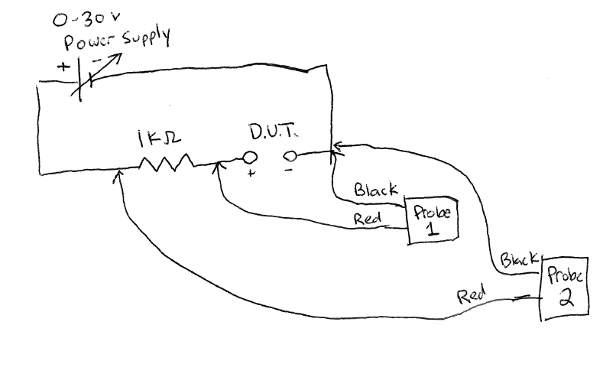

Note that we cannot connect “probe 2” directly across the reference resistor, because the black leads of the probes are internally connected inside the LabPro interface. If the black lead was connected to the right side of the resistor, current would flow through the black leads of both voltage probes and essentially “short out” the device under test. To measure the current through the 1K resistor, we will use Logger Pro to subtract the reading of Probe 1 from the reading at Probe 2, and divide the result by 1000 ohms to obtain the current in Amps (I=V/R).

Part I V-I Characteristic for a resistor.

- Make sure the power supply is turned off and plug it in. Do not turn on the power supply.

- Connect the circuit shown above, placing a 100 ohm resistor in the circuit as the device under test (DUT).

- Turn both voltage knobs (course and fine) on the power supply fully counter-clockwise, and turn the “fine” current knob fully clockwise and the “course” current knob fully counter-clockwise. This will limit the available current in case the output of the power supply is unintentionally shorted.

- In Logger Pro, open the “VI curve.cmbl” file that can be downloaded from the course webpage. When the file is loaded, Logger Pro will be set up to calculate the current from the two voltage readings and plot the current vs. the voltage of the DUT.

- Turn the power supply on and press the “collect” button in Logger Pro.

- When the data collection begins, slowly turn the “course” voltage knob, but stop when the voltage reading on the power supply reads about 9V. You should see something similar to the following curve:

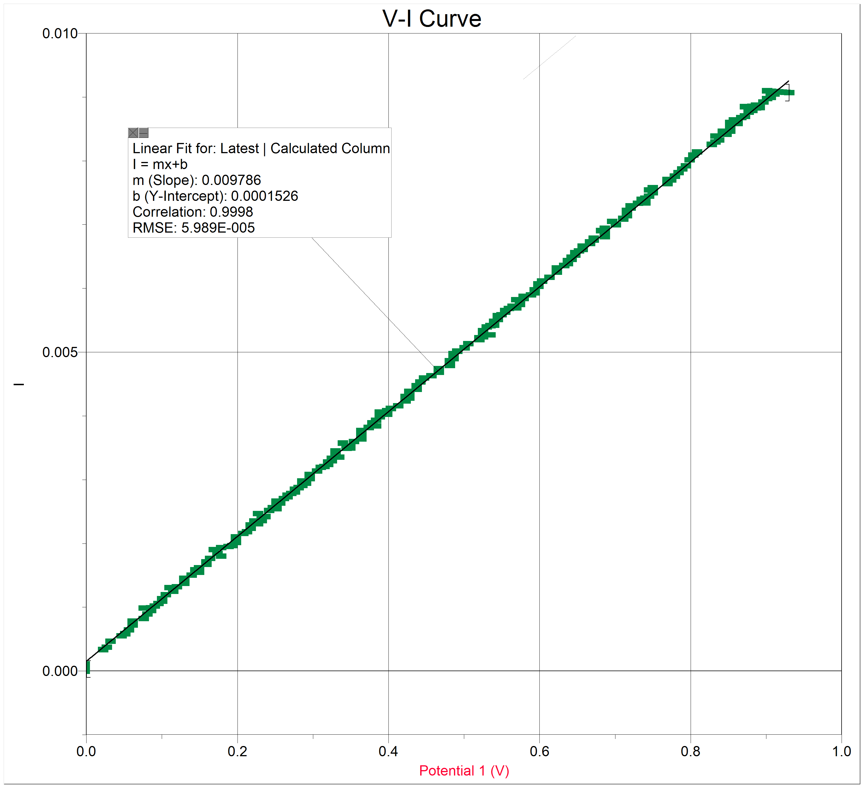
- Perform a linear fit on the data and use the information from the fit to obtain a value for the resistance of the DUT. Comment on the quality of the fit and the accuracy of your data. Does the measured value of the resistance lie within the tolerance of the resistor you are measuring?

- Repeat the experiment for a different resistor with a resistance in the range of 10 Ohms to 1000 Ohms.

Part II Nonlinear devices

- Turn the voltage knob of the power supply fully counterclockwise.

- We will now measure the voltage-current characteristic of an LED (Light Emitting Diode). We will start with a red LED. When connecting the LED to the test circuit, be sure to observe the polarity shown in the figure below (connect the anode to the 1K reference resistor and the cathode to the “-“ terminal of the power supply and the black leads of the voltage probes).

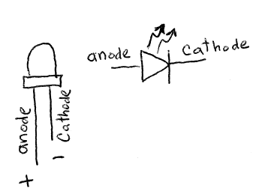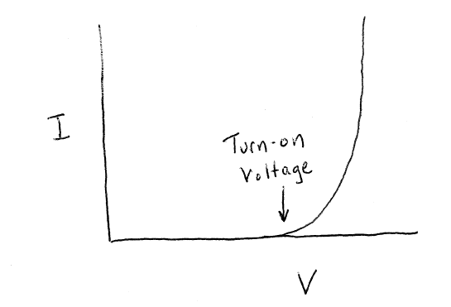
- Measure the V-I characteristic of a red LED. In an excel spreadsheet, record the “turn-on voltage” which is the voltage at which the current begins to flow in the LED. Also record the wavelength of light emitted by the LED in the spreadsheet. (700nm for the LN21RPHL LED)

- In Logger Pro, select the “store latest run” under the “experiment” menu to record the data and plot the next curve on the same graph. Measure the V-I characteristic of a blue LED. What is different between the two curves? Record the turn-on voltage and the wavelength for this LED in your spreadsheet. (P467-ND wavelength 470nm)

- Repeat the experiment for an Orange LED (LN81RPHL or LN81RCPHL, wavelength 630nm)

- Repeat the experiment for an Amber LED (LN41YPHL or LN41YCPHL, 590nm)

- Repeat the experiment for a green LED (LN31GPHL or LN31GCPHL, 565nm)

- Plot the Turn-on potential as a function of the light frequency . Do you see a relationship between the “color” of the LED and the “turn-on” potential?

Mystery LED
- Get a “mystery LED” from your professor and connect it to your V-I apparatus. Cover the mystery LED with something that will hide it when it glows. Record the I-V characteristic and use it to predict the color of the LED. Were you correct?

Part III Play Doh resistors

Remember that the resistivity, ρ, is a property of a material. The resistance, R, of a particular object depends on its geometry. For an object of length L carrying a uniform current perpendicular to its cross-sectional area A, the resistance is given by . In this section, we will determine the resistivity of Play-Doh ™. In order to do this, we will need to perform something called a “four-point measurement” (or four-probe measurement). To see why this is necessary, consider the following diagram:
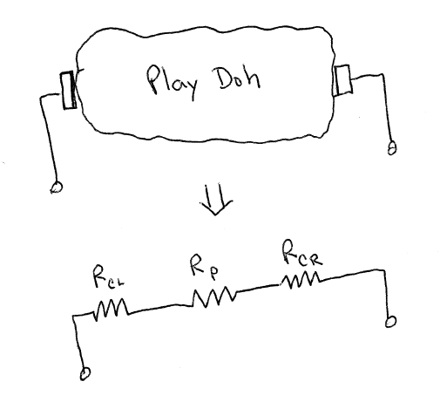

When a current is passed through the “contacts” to the play-doh, chemical reactions change the resistance of the material near the contacts. The resistance of the contacts can possibly exceed the resistance we are trying to measure, resulting in a very inaccurate reading. We want to set up a situation where the measurement is not sensitive to the contact resistance. Consider the following:
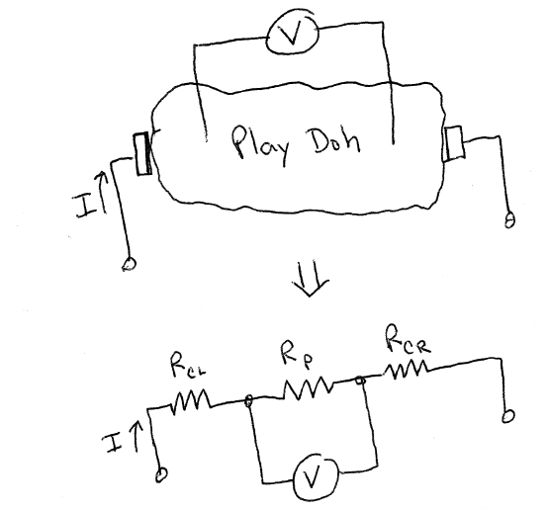

In this case, if the current through the outer contacts is known, we can use a voltmeter to measure the potential difference of a section of the sample. The current flowing through the voltmeter leads is negligible, so the contact resistance at the voltmeter contacts does not contribute significant error to the measurement. We can then use Ohm’s law (V=I*R and and ) to obtain a value for the resistivity. Note that we must use the length between the voltmeter probes for L in this expression. (Why?) Also note that the voltmeter leads should be placed far enough away from the current leads so that the current is uniform in the region which you are measuring.

- Construct a play-doh resistor with a uniform cross-section. Your resistor should be at least 4 times longer than its other dimensions (width or height or diameter).

- Connect a 30V power supply in series with a current meter to the ends of your play-doh resistor. Connect a voltmeter to the play-doh resistor to perform a four-point measurement as outlined above.

- Record the current and voltage values for several different currents. Use these values to compute the resistivity of play-doh. You may want to create an excel spreadsheet to record your measurements and calculate the resistivity

- For two additional geometries of play-doh resistors, measure the resistivity of play-doh and compare the values you obtain. Be sure to comment on the quality of your data. Also be sure to discuss any sources of error and ways the error could be reduced.

