Lab2
Electric Potential

1. The electric potential in a charge-free region obeys Laplace’s equation which can be solved by a “relaxation” technique where each element in a grid is computed to be the average of the adjacent elements. Create an excel spreadsheet with “0” along the borders of a square region with a width of 100 elements and a height of 100 elements. Create a formula for the interior cells that calculates the average of the left, right, upper, and lower adjacent cells (the 4 “neighbors”). Excel will complain about circular references, so you need to enable iterations by selecting tools-options- then the calculation tab- then check the iteration box. Paste the formula across the interior cells (leaving the zeros on the border). Put a constant “1” in the middle of the spreadsheet (overwriting the formula there). Press F9 to recalculate the spreadsheet a few times until the numbers settle. Create a surface plot like the one shown below.
This is the normalized potential from a point charge.

- Plot a contour plot of your data, and print it out. Then draw the electric field lines on the printout.

- Plot a “slice” through the middle of your spreadsheet. Calculate the “expected” value for the potential from the middle of your spreadsheet out to the edge and plot the calculated (1/r) curve on the same graph as your data that was computed by the relaxation technique. Do the curves match? Discuss any deviation from the expected value.

- For the conductor distribution shown below, compute the potential and plot it on a 3-d graph as shown above. Also generate a contour plot and draw the electric field lines on the plot.

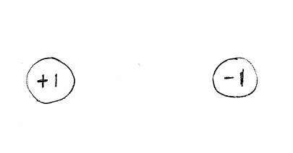

- Repeat the previous step for the conductor arrangement shown below:

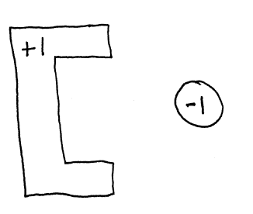

- Again, repeat the previous step for the conductor arrangement shown below:

