General Physics Lab
Magnetic Induction

Faraday’s law:
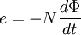

Ampere’s Law:
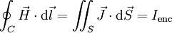

Purpose
In this lab, you will see Faraday’s Law and Ampere’s law in action. A coil of wire around a ferrite core will produce magnetic flux in the core. According to Ampere’s law, the current through the coil that is producing the flux is proportional to the flux through the core. The flux is also proportional to the number of turns of wire that wrap around the core.

When a second loop of wire is threaded through the core, an emf is induced in the second wire when the flux through the core changes. In this lab, you will use a function generator to produce varying magnetic flux. Using an oscilloscope, the induced emf in a wire threading through the core will be measured. The number of turns of wire through the core will be varied and the resulting induced emf will be measured. The relationship between this emf and the functional form of the flux will also be explored.

Procedure.

Set up the experiment as shown below

- Set the function generator to a frequency of about 100KHz, and output a sine wave. Adjust the amplitude of the output until the peak to peak voltage across the resistor measures about 10V. What current through the coil of wire corresponds to this reading?

- Thread one turn of wire through the core and measure the induced emf on channel 2 of the oscilloscope. Measure the peak-to-peak amplitude of this induced emf and record the measurement in a datasheet. You should see something similar to what is shown below (this is for two turns on the oscilloscope side).
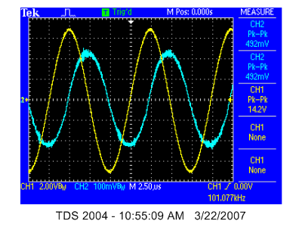
- Unthread the wire completely out of the core and connect it back to the oscilloscope. Try to put a loop of wire through the core to get an induced emf. Is there anything you can do (twisting the wire, putting it near the core) to get an induced emf without disconnecting the wire from the oscilloscope? Explain the results of this investigation.

- Now change the number of turns of wire in the second coil of wire and repeat the amplitude measurement. Collect at least 10 data points (one turn through 10 turns). Record the data in a spreadsheet.

- Plot the induced emf vs. the number of turns and fit the data to the expected function. How well do the data fit the expected curve?

- Set up the circuit with 10 turns on the function generator side and 5 turns on the oscilloscope side. Compare the amplitude of the measured signal on channel 2 to the signal measured for 20 turns on the function generator side and 5 turns on the oscilloscope side.

- Now change the “function” of the function generator to a triangle wave. Set up the circuit to have 20 turns on the function generator side and 5 turns on the oscilloscope side. Measure the induced emf and capture the oscilloscope screen to the computer for inclusion in your lab report. You should see something like the screen shown below
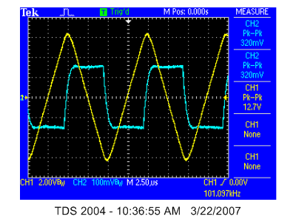

- Describe the relationship between the flux and the induced emf. Does the data obey Faraday’s law?

- Now switch back to a sine wave output and capture the screen for your lab report. Again discuss the relationship between the flux and induced emf and if Faraday’s law is obeyed.

- Finally, switch the output of the function generator to a square wave and repeat the last step.

