General Physics II LAB
Magnetic Fields

- Set up the apparatus shown above. Pay close attention to the alignment of the coil and the dynamics track. The coil and track should be perpendicular, and the magnetic field sensor should be perpendicular to the coil and aligned as closely as possible with the axis of the coil. The string should go around the middle part of the 3-step pulley on the rotary motion sensor.
- Connect the coil to the power supply through a 1ohm 5W resistor as shown above.
- With the magnetic field sensor in the center of the coil, measure the magnetic field from the coil as a function of the current through the coil. You should set up an experiment in Logger Pro so that the current is displayed on the x axis and the magnetic field is displayed on the Y axis.
- Perform an appropriate curve-fit on the data and compare your results with the expected value. Comment on any sources of error and discuss the quality of your results.

Part 2 – On-axis magnetic field from a loop

- Experimentally determine the magnetic field in the center of a 200-turn coil as a function of the current through the coil. To do this, you will use the rotary motion sensor to measure the distance from the center of the coil to the detector. You will need to set up the rotary motion sensor so that it measures distance. Go to the “Sensor Settings” menu for the sensor and set it to match the following:
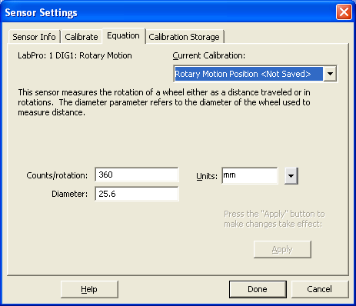

- Set up the data collection so that it records for 20 seconds. Configure a graph to display magnetic field vs. distance. Set the power supply so that it is supplying 2A to the coil. Use the current knob to do this so that temperature changes in the wire will not change the current. With the magnetic field sensor starting as close as possible to the center of the coil, start the data collection and slowly move the block back, keeping the sensor perpendicular to the coil. Be sure to keep the sensor as close as possible to the coil axis as it is moved back.
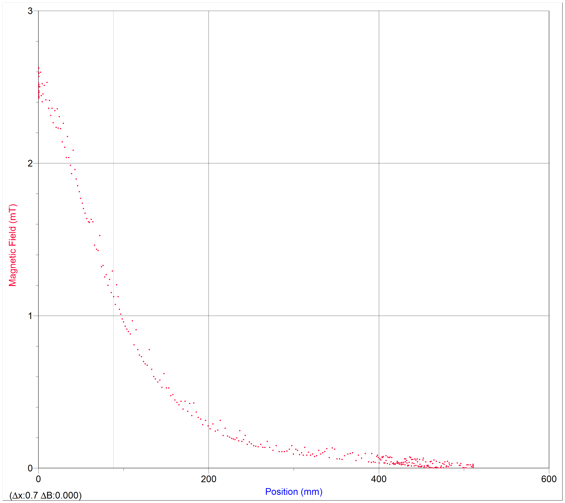

- Plot the expected function on the same graph and include a graph with both the experimental and theoretical curves in your lab writeup. Comment on any deviation from the theoretical values and comment on sources of error and the quality of your data.

Part 3 – Magnetic field in a slinky

- Now we want to measure the magnetic field in the middle of a slinky ™. Connect a power supply to the slinky, and place the slinky on a table next to a meterstick. Set the power supply to deliver 2A of current through the slinky.

- Stretch the slinky different amounts so that the spacing between the coils changes, and measure the magnetic field for different “winding” densities. To get the coil density, measure several coils and divide the number of coils by the distance you measure.

- Plot the magnetic field vs. coil density. Fit the data to the expected function, and comment on the results of the fit.

