General Physics Lab 3
Capacitors and Dielectrics

In this lab, we will measure the dielectric constant of some plastic sheet, and design a capacitor with a target capacitance. We will also explore series and parallel combinations of capacitors.

Preliminary Questions

- How would you measure the dielectric constant of a material, if you have a way to measure only capacitance and distances directly?

- For the structure below, what is the capacitance “between” points A and B, B and C, and A and C. If points A and C are connected with a wire, what is the capacitance between points A and B? For each case, draw the equivalent schematic.

Procedure.

Part I Determining the dielectric constant of a material

- Glue two 10cm by 10cm pieces of aluminum foil to a slightly larger piece of plastic sheet. When cutting out the square pieces of aluminum foil, leave tabs sticking out so you can connect leads and measure the capacitance.

- Using a micrometer, measure the thickness of 10 pieces of the plastic (on top of each other) to get a reasonably accurate measurement of the thickness of one piece.
- Measure the capacitance of the structure that you have just constructed. Using this value, calculate the dielectric constant of the material. Note that you should take a “zero” reading of the capacitance by disconnecting the leads and leaving the leads in the same position. This “stray” capacitance should be subtracted from the reading.

Part II Design your own capacitor

- Using the information you have measured and calculated so far, design and build a 2nf capacitor. Measure the capacitance and comment on any differences between the design value and the measured value
- Glue an additional plastic sheet and foil plate onto the capacitor you built in part 4. Use this “3-plate” capacitor to verify your answer for the second preliminary question.

Part III cylindrical capacitor

- Now make two 15cm x 2.5cm strips of aluminum foil. Cover the two pieces of foil with two strips of double-stick scotch tape. Make sure that the gap between the two pieces of tape is as small is possible and that the two pieces of tape do not overlap.
- Measure the capacitance of this structure and the thickness of the tape. What is the capacitance of this structure?
- Place another two pieces of tape on the top of the capacitor from part 6, and roll it as shown below. Measure the capacitance. How does this compare to the capacitance you measured when the structure was not rolled up? How do you account for this change?

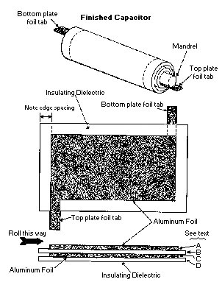

Part IV Series and Parallel combinations of capacitors

9. Using only 0.1 microfarad capacitors, how would you construct a 0.15 microfarad capacitor? Using the capacitors in the lab and the capacitance meter, test your answer

